The Sub Menu Part 3

Contents

The Viewport Gizmos 3

Show Overlays 4

Viewing Mode Options 6

Wire Frame 6

Solid 7

Material 7

Render View Mode 9

The Drop- Down arrow at the End of the View Menu Items 9

Right side Panel Gadgets 15

Zoom 15

Pan 16

Camera View Button 16

The Grid Button 17

The Right Click Menu 19

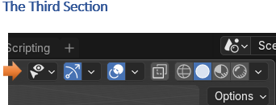

We will start with this part of the Menu here

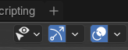

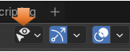

The first one has to do with visibility and select-ability of the different elements on the viewport screen. This can be very important because if you have an item in the way of another you can hit the eye and turn it off. Notice that the eye is also available in the Scene collection and you can hide something from view here too.

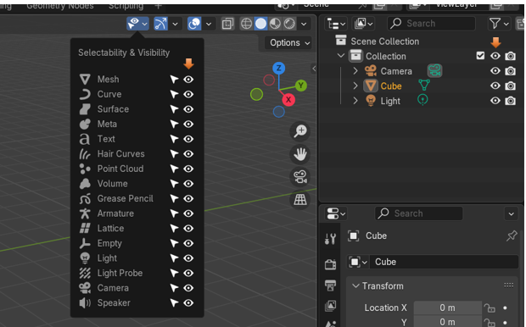

Now the select-ability icon is the one that looks like a little white arrow. This is important too, because if you do not want to move or interfere with an object on the screen, and you like it just as it is, you can hit the arrow and then it is locked and cannot be messed with.

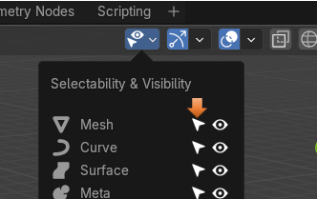

You can also do this from the Scene collection panel, but you must first open a menu at the top to get to it. Open the menu that looks like a funnel at the top of the Scene collection and you will see it.

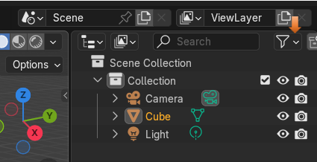

Click on the item on the viewport that you want to make non-selectable and then hit the little white arrow.

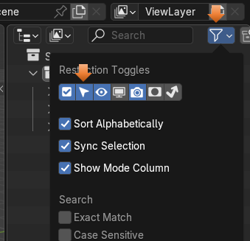

# The Viewport Gizmos

This one has to do with turning on the Viewport Gizmos. These are the images that show up in the viewport that help you be able to manipulate your object. They look something like this.

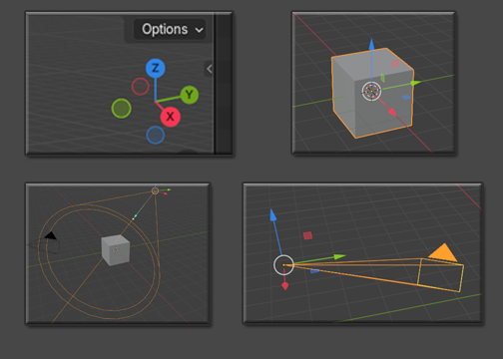

This is what the menu will look like. Just check and uncheck the different boxes to see the Gizmos disappear.

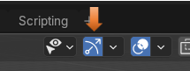

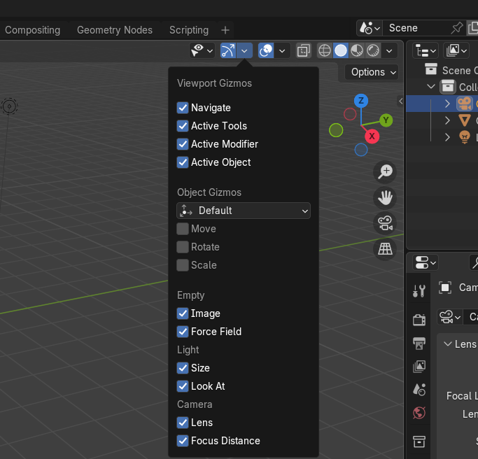

# Show Overlays

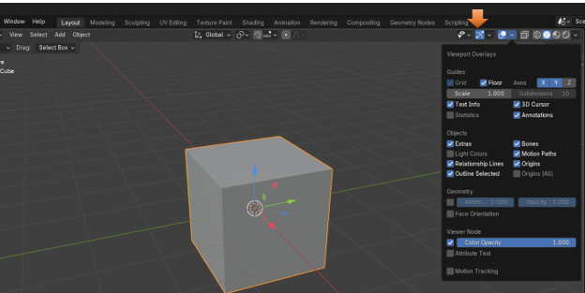

This first section will enable you to turn on and off the floor Grid

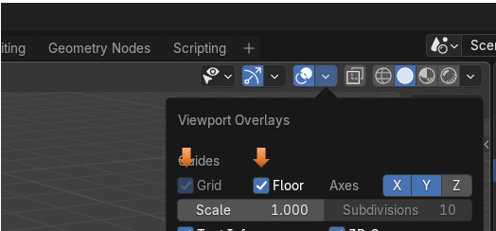

Unselect the boxes to turn off the grid on the floor

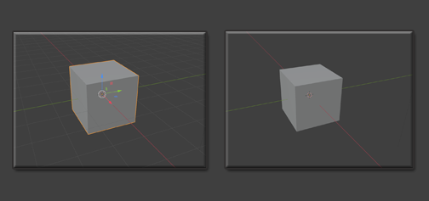

Another section which can be used in this part is to turn off the 3D cursor, which can sometimes get in the way when we are trying to fine tune our 3D models.

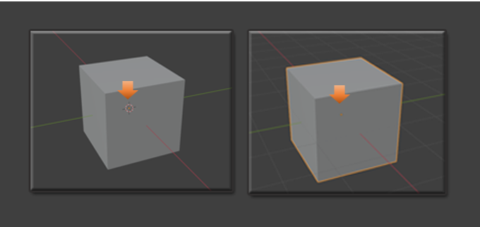

# Viewing Mode Options

This next section of menu items will deal with the viewing modes.



1. Transparent
2. Wireframe
3. Solid
4. Material
5. Render

These are all of the different Viewing modes in which you can set up your 3D model. Now you can turn on Transparent view to work with both the Wireframe mode and the Solid mode, which comes after it, but you will find out that this mode of Transparent will be disabled, and greyed out if you go into Material Mode View, or the Render View. That is because these two views will deal with the materials and render will deal with sunlight and shadow, and transparent makes little sense when wanting to test in these modes.

You can use Solid and Wire View mode also with out the Transparent button turned on and then you will not have them be see through. It just depends on what you want.

# Wire Frame

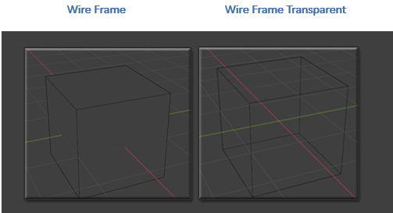

# Solid

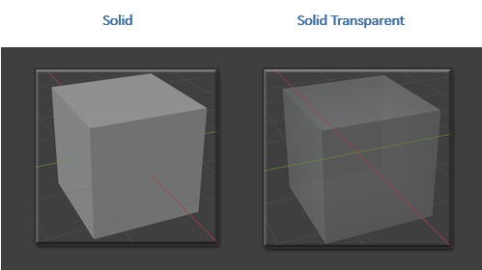

## 

# Material

Material, will show us our Material color that we added to the object in the Shader Workspace

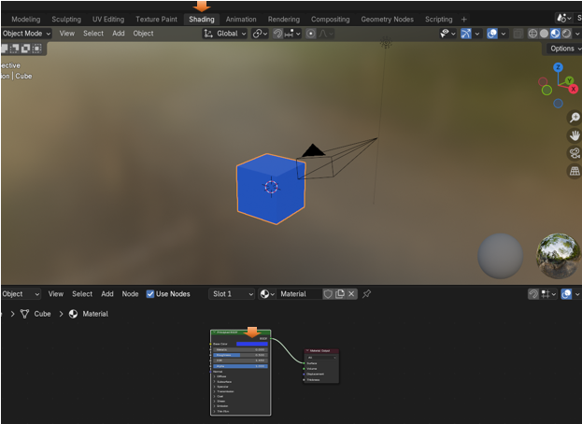

When we are in Solid View, we only see that gray looking Cube

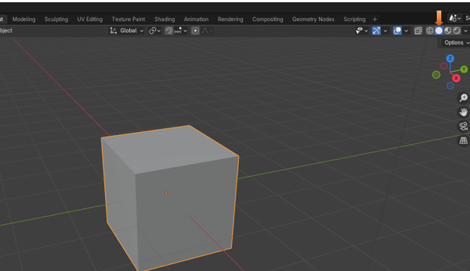

But we move over into the Material View mode, and we see the color that we added.

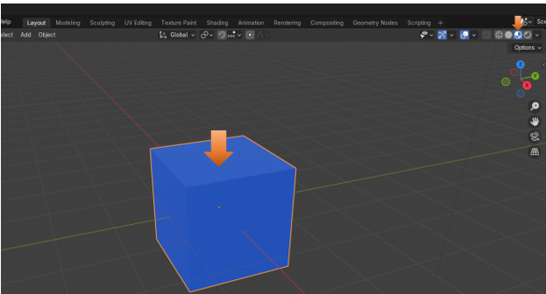

# Render View Mode

Render View mode will give us our shadows and highlights, and it is the way it will look when we render the object out, from the Render Menu.

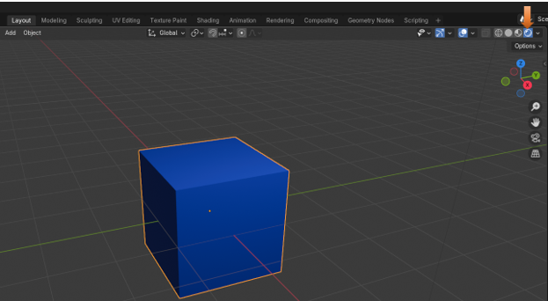

# The Drop- Down arrow at the End of the View Menu Items

You will find that you have a tiny little arrow at the end of the View Menu Items.

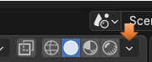

You will find that most of the different view options will not actually give you much.

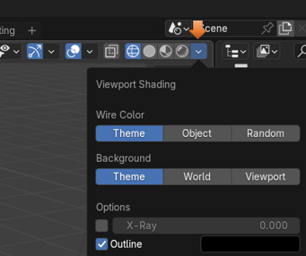

Until you turn on the Solid mode, and then hit this arrow button. Then you get all of this.

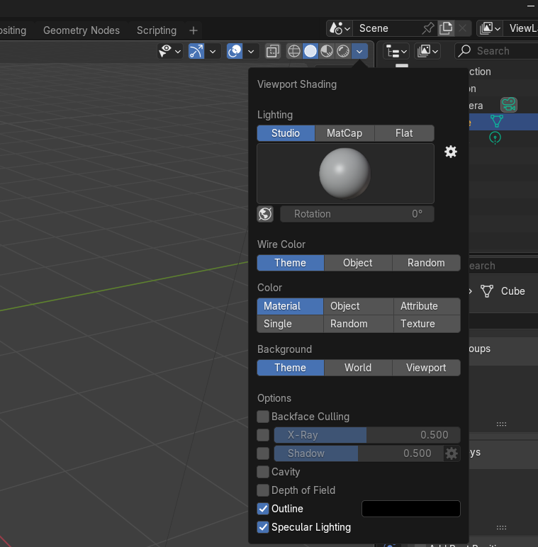

The most interesting part of this drop- down menu is the Section under Color. You can have that Material button selected, and then click on the Single button, and select a color. This only gives you a fake color and you can only view it in the viewport when you are in solid mode, you will find if you go to material or render, that your color disappears. See you have a color swatch that you can choose a color to view in solid mode.

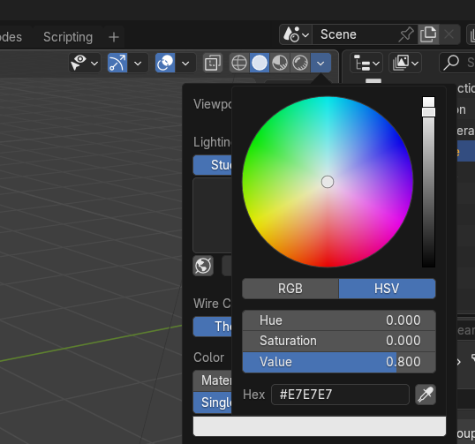

Change it to a red here, and the cube changes color and we are in Solid view mode.

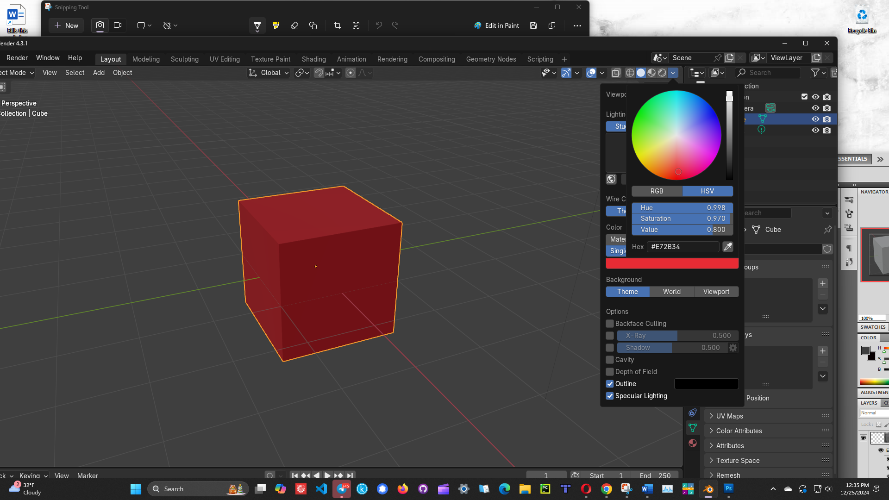

But go back to Render view mode, and you will find that it is still showing the color that we applied to it the right way, by doing it through the Shading Workspace, and applying the color on a node.

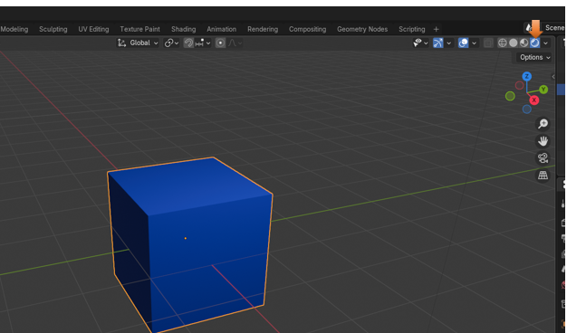

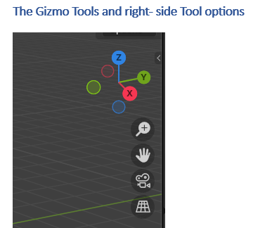

Just hit one of the colored arrows to spin the view of the object around



This little colored Gizmo, is used to spin your object around in all different directions. Click on each of the colored arrows to spin your cube around in the viewport.

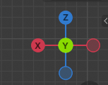

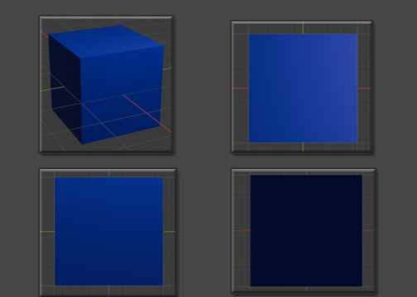

# Right side Panel Gadgets

Now this is nice, although, for moving around in the viewport, you may find your middle mouse tool, to be faster. But here you have a zoom tool, a pan tool, a camera view tool and the grid on or off tool.

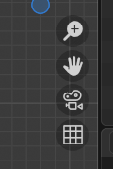

# Zoom

Hold down on the Zoom button on the right-hand side and then just move the mouse around to zoom image, with the left mouse button instead of the middle mouse wheel.

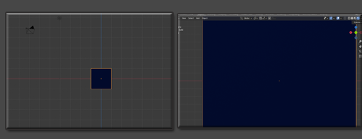

# Pan

Hold down the Pan button on the right-hand side and then just move the mouse around to pan the image, with the left mouse button instead of the middle mouse wheel.

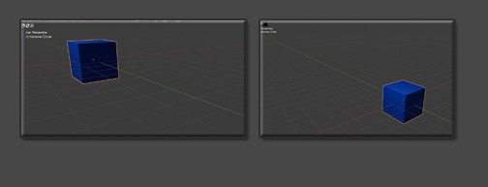

# Camera View Button

If you click on the Camera, you can view your object in Camera View

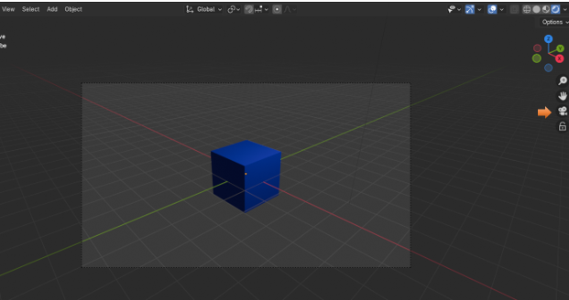

When in Camera view, you will see a lock under the camera. Here you can lock the cube inside of the camera or allow it to move around.

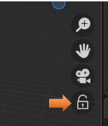

Make sure you come out of Camera View, by clicking on the button again to toggle out, and to see the Grid button

# The Grid Button

The Grid button will toggle on and off Orthographic and perspective view

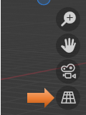

Click on the grid, and watch the grid floor change the box from a straight on view to the perspective view. Click on the button to toggle between Orthographic and Perspective views.

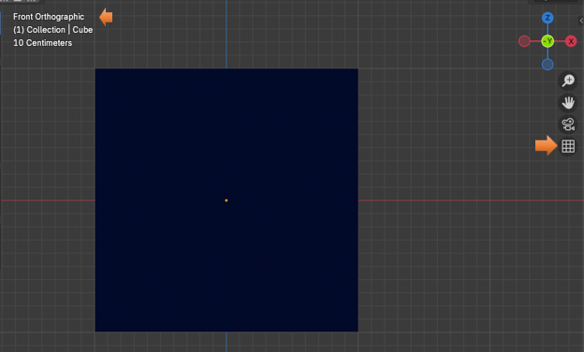

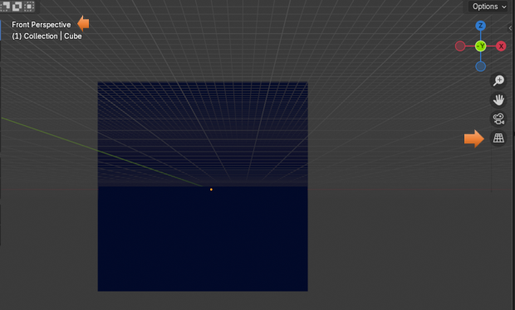

# The Right Click Menu

The right click menu in the viewport is the last, of course you do have that huge panel at the right. But that is best to go into slowly during some future lessons. This right click menu is also quite large, but I will give you an introduction to it here.

You will see that you are able to do things, like shade the object smooth, duplicate the item, copy it, rename it, insert keyframes, and a whole lot more. The further you get into this program the more you will appreciate the easy availability of this right click menu.

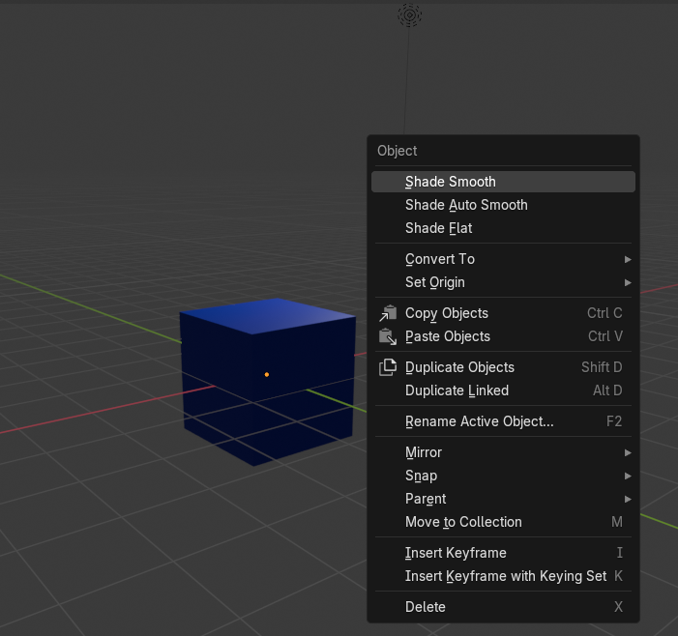

Well, that brings this week’s subject matter to a close. Next week, I hope to introduce you to doing something inside of Object mode.